The Beginnings of Civil War
The second son of James VI of Scotland and Anne of Denmark, Charles was born at Fife in Scotland on 19 November 1600. His father succeeded Queen Elizabeth I and came to the throne of England as King James I in 1603.
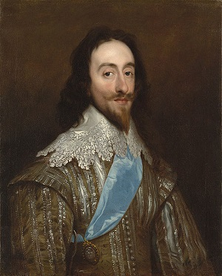
With a strong belief that Kings were appointed by God to rule by Divine Right, Charles succeeded James as the second Stuart King in 1625.
Charles allowed England's foreign policy to be directed by the unpopular Duke of Buckingham, who launched a series of disastrous military expeditions against Spain and France. Charles dissolved his first two Parliaments when they attempted to impeach Buckingham, but he was forced to call a third because he needed funds to pursue his warlike policies. In 1628, Charles' opponents formulated the Petition of Right as a defense against the King's abuse use of his powers. Charles reluctantly accepted the Petition in the hope that Parliament would grant him money for war, but in practice he ignored its provisions.
After the assassination of Buckingham in 1628, critics in Parliament turned their attention to Charles' religious policy. He angrily dismissed his third Parliament in 1629, imprisoned several of his leading opponents, and declared his intention of ruling alone. The eleven-year period of the King's Personal Rule was also described as the "Eleven Year Tyranny". It was initially successful — Charles had made peace with Spain and France by 1630. Trade and commerce grew; the King's finances were stable by 1635. But without Parliament to grant legal taxes, Charles was obliged to raise income by obscure and highly unpopular means including forced loans and the sale of commercial monopolies. Along with Charles' controversial religious policies, these measures alienated many natural supporters of the Crown.
Charles and his advisers made extensive use of the Court of Star Chamber to prosecute opponents. Dating back to the 15th century, Star Chamber had originally been a court of appeal. Under the Stuarts, it came to be used to examine cases of treason, which in practice meant that the court could be used to suppress opposition to royal policies. Star Chamber sessions were held in secret, with no indictments, no right of appeal, no juries, and no witnesses. It became synonymous with the King's misuse of his power during the Personal Rule.
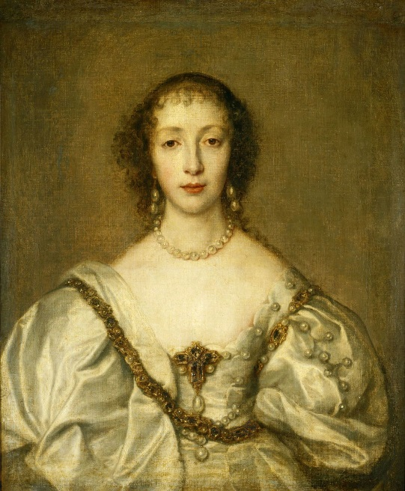
In religion, Charles favored the elaborate High Anglican form of worship. He appointed William Laud Archbishop of Canterbury in 1633. Laud insisted upon strict following of the established beliefs of the Church and strongly supported the King's Divine Right. Laud also made extensive use of Star Chamber to suppress opposition from Puritans who regarded the High Church liturgy as dangerously close to Roman Catholicism. The King's marriage to the French Catholic princess Henrietta Maria also caused dismay amongst English Protestants, particularly as she was allowed to practice her religion openly and freely. In some quarters, Henrietta Maria's influence over the King and the royal children was regarded as part of an international Catholic conspiracy against the Protestant faith.
Although Charles himself was high-minded and devout, his religious policies bothered many people and turned Puritans like Oliver Cromwell against him. In collaboration with Archbishop Laud, he insisted upon everyone using the same book in England, Scotland, and Ireland. This went disastrously wrong and started a war with the Scottish (who were Calvinists, not Anglican) in 1637. In order to finance war against the Scots, Charles was obliged to recall Parliament in 1640, bringing his eleven-year personal rule to an end.
In November 1641, news of an Irish uprising reached London, provoking a crisis over whether King or Parliament should control the army that was needed to suppress the rebellion. Not trusting Charles to put down the Irish, Parliament insisted on being in charge of the army. Charles refused to listen. Instead, Charles raised his own army and attempted to arrest some of his biggest opponents. As a result, the Civil War began.

Questions: Please answer the following in complete sentences.
1. Divine Right of Kings is defined as when a monarch believes he has the right to rule from God, which often gave monarchs the power to do whatever they wanted. What actions of Charles’ illustrate his personal belief in the divine right of kings? (You should have at LEAST three things written here).

2. Why would English citizens dislike the Court of Star Chamber?

3. What effect does religion have on Charles’ popularity among Englishmen?

4. What problem led to the outbreak of the English Civil War?

