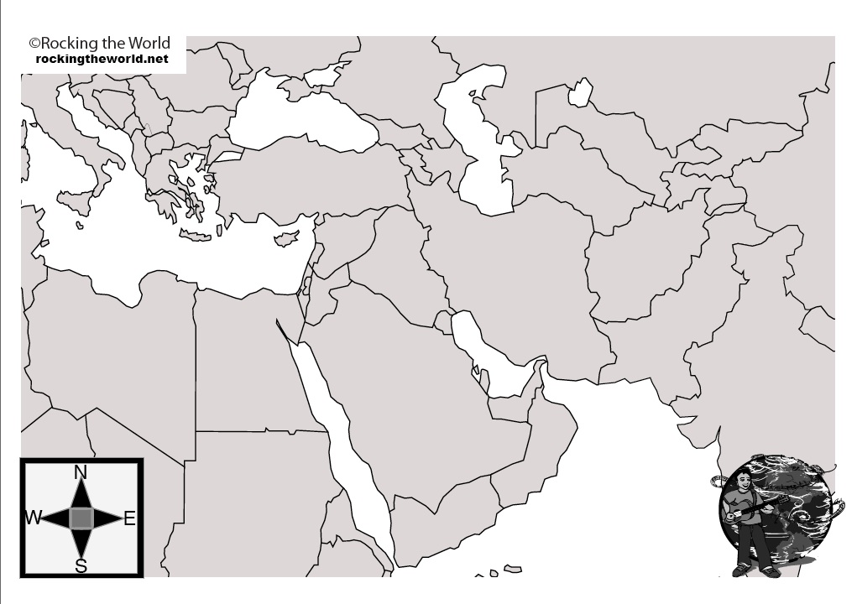

Locate the following locations on the map:
Egypt Iran Turkey Saudi Arabia Iraq Yemen

Syria Kurdistan Syria United Arab Emirates Israel Jordan

Palestine Lebanon Oman Kuwait Afghanistan Sudan

Pakistan Turkmenistan

