Name:
Mods:
Renaissance and Reformation Study Guide
Explain how each of the following led to the Reformation.
Behavior:

Indulgences:

Tactics of the Counter Reformation:
Inquisition:

Jesuits:

Council of Trent:

Index of Forbidden Books:

Know and be able to explain the significance of the following terms:
Black Death

Perspective

Idealism

Be able to identify the following people and explain their importance:
Henry VIII

Sir Thomas Moore

Shakespeare

Michelangelo

Guttenberg

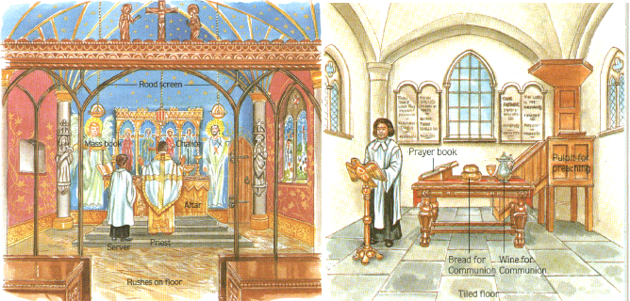

Given what you know about the causes of the Reformation and the beliefs of the branches of Christianity, which church do you think is Catholic and which do you think is Protestant? Explain your answer.

______________________________________________________________________________________________________________________________________________________________________________________________________________________________________________________________________________

3 reasons why Italy and not another European country, was the beginning of the Renaissance.
1.
2.
3.

Know the following vocab words and their significance. You do NOT need to redefine the words here.
Renaissance humanists Niccolo Machiavelli John Calvin
Predestination Reformation Sects Martin Luther
Counter Reformation

