Primary Source 1
Declaration of Independence
When in the Course of human events, it becomes necessary for one people to dissolve the political bands which have connected them with another, and to assume among the powers of the earth, the separate and equal station to which the Laws of Nature and of Nature's God entitle them, a decent respect to the opinions of mankind requires that they should declare the causes which impel them to the separation.

Primary Source 2
Declaration of Independence
We hold these truths to be self-evident, that all men are created equal, that they are endowed by their Creator with certain unalienable Rights, that among these are Life, Liberty and the pursuit of Happiness.- That to secure these rights, Governments are instituted among Men, deriving their just powers from the consent of the governed, --That whenever any Form of Government becomes destructive of these ends, it is the Right of the People to alter or to abolish it, and to institute new Government, laying its foundation on such principles and organizing its powers in such form, as to them shall seem most likely to effect their Safety and Happiness.

Primary Source 3
Declaration of Independence

But when a long train of abuses and usurpations, pursuing invariably the same Object evinces a design to reduce them under absolute Despotism, it is their right, it is their duty, to throw off such Government, and to provide new Guards for their future security.--Such has been the patient sufferance of these Colonies; and such is now the necessity which constrains them to alter their former Systems of Government.

Primary Source 4
The Constitution
Article. I.
All legislative Powers herein granted shall be vested in a Congress of the United States, which shall consist of a Senate and House of Representatives.
Article. II.
The executive Power shall be vested in a President of the United States of America. He shall hold his Office during the Term of four Years, and, together with the Vice President, chosen for the same Term, be elected, as follows
Article III.
The judicial Power of the United States, shall be vested in one supreme Court, and in such inferior Courts as the Congress may from time to time ordain and establish. The Judges, both of the supreme and inferior Courts, shall hold their Offices during good Behaviour, and shall, at stated Times, receive for their Services, a Compensation, which shall not be diminished during their Continuance in Office.

Primary Source 5
The Constitution
Article 6
The Senators and Representatives before mentioned, and the Members of the several State Legislatures, and all executive and judicial Officers, both of the United States and of the several States, shall be bound by Oath or Affirmation, to support this Constitution; but no religious Test shall ever be required as a Qualification to any Office or public Trust under the United States.

Primary Source 6
The Preamble of the Constitution
We the People of the United States, in Order to form a more perfect Union, establish Justice, insure domestic Tranquility, provide for the common defence, promote the general Welfare, and secure the Blessings of Liberty to ourselves and our Posterity, do ordain and establish this Constitution for the United States of America.

Primary Source 7
The Bill of Rights

Amendment I
Congress shall make no law respecting an establishment of religion, or prohibiting the free exercise thereof; or abridging the freedom of speech, or of the press; or the right of the people peaceably to assemble, and to petition the government for a redress of grievances.

Primary Source 8
Boston Tea Party Image
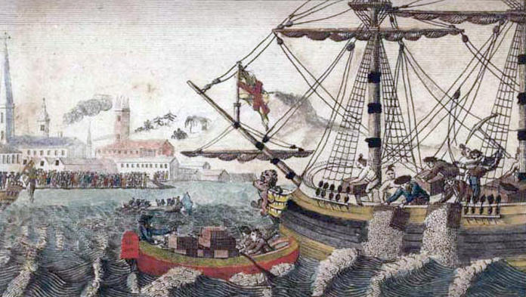
Source: W.D. Cooper. "Boston Tea Party." The History of North America. London: E. Newberry, 1789.

As a protest against a tax placed on imported tea by the British crown, a group of American colonists, led by Samuel Adams, staged the Boston Tea Party. On December 16, 1773, the colonists, some dressed as Native Americans, boarded three British ships and tossed the tea cargo into Boston Harbor.

