Name:
Mods:
Scientific Revolution

Science in the Middle Ages
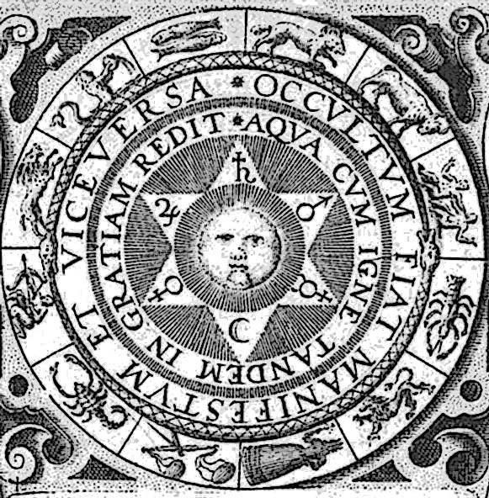
Until well into the 1500s, most Europeans saw little difference between science and magic. Alchemists used spells and magic formulas to try to change one substance to another—for example, lead into gold. Astrologers believed that the position of the stars in the sky influenced human life. This was all considered science. At the same time, however, tarot cards were used to predict the future while others created magic potions to cure illnesses or make someone fall in love with another. This was considered magic.
People still believed many explanations of natural events proposed by Aristotle almost 2,000 years earlier. These people were called natural philosophers. They relied on religious teachings and the works of classical Greek and Roman thinkers to explain the mysteries of nature.
Many scientists before the Renaissance were like Roger Bacon, an English philosopher and scientist of the 1200s. Bacon, a Franciscan monk who had studied at Oxford and Paris, was viewed as a leading scholar of his time. He was one of the earliest to favor a system of scientific experimentation, rather than faithful acceptance of religious ideas and ancient beliefs, as a means of finding truth. Nevertheless, he was shaped by the thinking of the time and mainly practiced alchemy. Famed for his teaching, Bacon became known as Doctor Mirabilis—wonderful teacher.

Influence of the Renaissance
The spirit of the Renaissance encouraged curiosity, investigation, discovery, and the practical application of the knowledge of nature to everyday life. Some people felt freer to question old ideas and beliefs. They were more willing to use new approaches to answering questions about the natural world. During the era of the Scientific Revolution, people began using experiments and mathematics to understand these mysteries. The study of nature became more organized. They were no longer content to explain the world in terms of religious thought, magic, or the ideas of ancient writers.
This new approach produced answers to many questions in physics, astronomy, and anatomy. It formed the basis for what we know today as science. Before the 1500s the word science meant "to know." After the 1500s the sense of the word changed into the narrower meaning it has today.
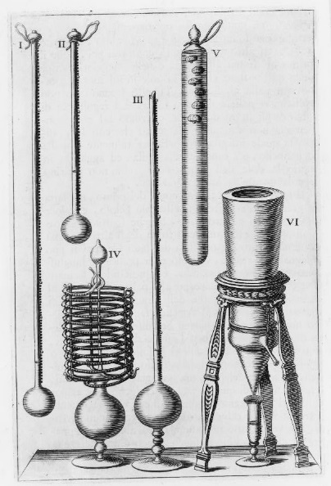
As scientists spent more time examining the world around them, they observed things that did not agree with traditional explanations. For this reason, early scientists of the 1500s began to question ancient beliefs. They learned to form conclusions based on what they could observe with their own senses. They also used three new tools—scientific instruments, mathematics, and experiments. This new approach to study and knowledge marked the beginnings of the Scientific Revolution. It was a turning point in thinking that led to a rapid increase in people's understanding of the world.
The ability to conduct experiments was key to this new approach to learning. Scientists used newly invented instruments such as the barometer, the microscope, the telescope, the air pump, and the thermometer. These tools greatly improved their ability to observe and measure. Scientists used mathematics to check and apply those measurements. Also, they repeated their experiments to make sure they got the same results. Then they drew conclusions about what they observed. This manner of study is called the scientific method.
The scientific method allowed for some of the best scientists to make new discoveries that still impact our world today. Men like Isaac Newton, Galileo, Copernicus, and Kepler would emerge during this time to invent, investigate, and explain the way the world works to a population finally able to understand and eventually accept their new ideas as truths.

Questions: Write down the answers as we go over them.
1. How would you describe science during the Middle Ages?

2. What effect did the Renaissance have on the Scientific Revolution?

3. What is the scientific method?

